Broomfield Primary School


Maths Calculation Policy
December 2022
Review Date : December 2023

Broomfield Primary School
Calculation Policy 2022
The National Curriculum’s three aims are embedded within this policy, as is ‘mastery’ pedagogy. The CPA approach (Concrete, Pictorial, Abstract) is advocated in EVERY year group. Understanding is key.
This calculation policy is intended to bring consistency, continuity and progression as methods build upon each other from the early years foundation stage (YR), to year 6.
It is essential that rapid recall of key number facts is embedded prior to written calculations being taught. This is necessary as the written calculations outlined in this policy rely on mental strategies to process numbers efficiently and with confidence. Therefore, mental strategies are included within this policy.
The links between subtraction, addition, division and multiplication are constantly reinforced throughout all year groups. These are particularly relevant when looking at the number facts. The concept of the inverse operation will really help the children develop the ability to complete mental calculations and the term will be introduced to Year 3. Children will also be encouraged to use this to check their workings out.
Children’s understanding of place value is central to all of these calculation processes. Developing an understanding of numeracy, quantity and the number system is of intrinsic importance to the ability to be successful in calculation. Therefore, structured place value apparatus (e.g. base 10) are on the tables when children are working through a new calculation method to help them see this relationship and to develop their understanding of the processes they are working through. This will provide visual images and models of the numbers and allow children to develop a strong sense of numeracy.
As part of every lesson, emphasis will be made on mathematical vocabulary and children should have access to written vocabulary at all times to ensure they can recognise and spell them as well as use it in their explanations.

Year | Addition & Subtraction
YR | Children count fluently in 1’s from 1 to 20. [Forwards and backwards]  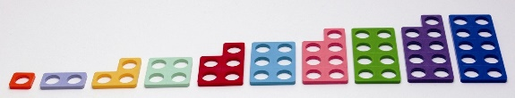  Children are encouraged to develop a mental picture of the number system in their heads to use for calculation.  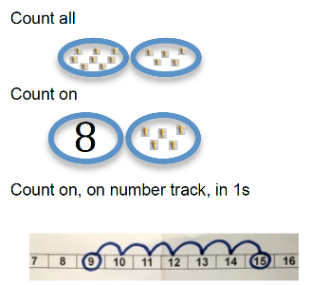  They can use this image again to calculate ‘1 more’ [then ‘1 less’] and find ‘1 more/less’ on a marked number line.  They begin to count on/back from any number using ‘1more/less’ knowledge.  They should experience practical calculation opportunities using a wide variety of equipment, e.g. small world play, role play, counters, cubes etc.  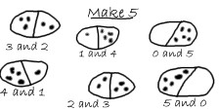  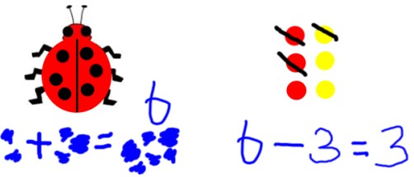  They develop ways of recording calculations using pictures, etc.  Children will recognise and use + = - signs and understand addition as combining 2 groups and subtraction as taking away from a group. | 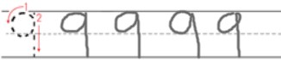  They learn to write numbers carefully.  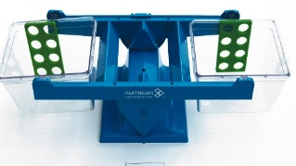  Children understand the = sign means is the same as, not makes, and that children see calculations where the equals sign is in a different position, e.g. 9 – 5 = 4 and 4 = 9 - 5  Children who are ready may record this as:  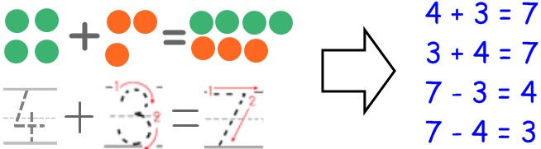  “If 7 is the whole, 3 is a part and 4 is a part.”
YR | By the end of EYFS most children will:  - say numbers in familiar contexts such as number rhymes or in role play  - recognise, count and order numbers up to 20  - use the vocabulary involved in addition and subtraction  - recognise differences in quantity of everyday objects and to find one more or one less  - understand the vocabulary of addition and subtraction in practical activities and in solving practical problems  - know the +, = and - signs  - know number bonds to 10 |  | Vocabulary  Numbers, one … twenty,  count, order, add, and, plus, take away, subtract, minus more, less, equal, same as,  Part-part whole
Year | Multiplication and Division
YR | Children are able to solve simple problems involving doubling. [In context]  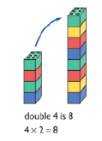  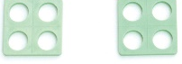  ‘4 and 4 equals 8’  ‘4 + 4 = 8’ | Children are able to solve simple problems involving halving and sharing. [In context]  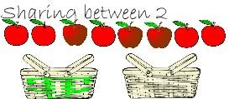  “Sharing equally between.”  Half of 8 is 4
YR | By the end of EYFS most children will:  - recall all doubles to 5  - know that halving is the same as sharing between 2 and using this to solve simple problems  - know what is half of all even numbers to 20 |  | Vocabulary  equal, same as,  double, half, share equally between

Year | Addition | Subtraction
Y1 | Mental Methods  Record addition by showing jumps on marked number lines  Or moving onto higher numbers  with the hundred square:  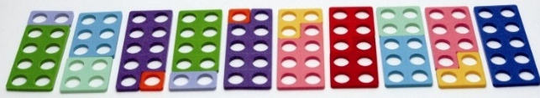  They will memorise number facts to 10 (then 20) in several forms establishing addition and subtraction as related operations.  They will record simple mental addition using + and =  Written Methods  Children will be encouraged to count on using practical resources e.g. fingers, cubes… to combine groups of objects to find the totals.  E.g. 6 + 5 = 11, start with 6 and use part of the second number to fill the ten-frame, then add on 1 more.  Use a number line to ‘bridge’ through 10.  e.g. ‘9 add 5’.  They will move on to the use of number lines and Base 10 equipment to support their developing understanding of addition [adding 1, or 10]
  Mental Methods
  Children understand subtraction as ‘take away’.
  They use practical equipment.
  e.g. Alex has 12p. I take away 4p from him. How much does he have left?
  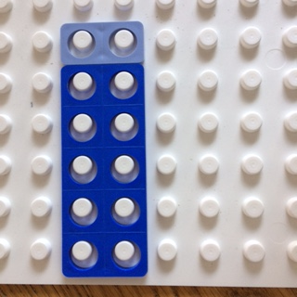
  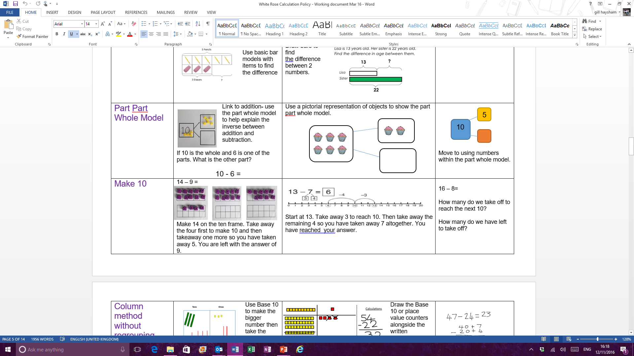
  Bridging through ten. E.g. 14 – 5 = 9
  Use a marked number line to count back:
  e.g. 6 – 4 = ?
  In preparation for understanding how to find the difference by comparing two amounts, children should be shown that finding the difference is linked to subtraction and an appropriate strategy to use when the numbers are close together. e.g. 13 - 9
  “The difference between 13 and 9 is…”
  To find the difference, children need to compare the two amounts. Ask “How many more?” [or less]
  The next stage is to make the smaller amount the same size as the larger amount by counting on:
  9 + ? = 13 “If 13 is the whole, 9 is a part and ? is a part.”
  Written Methods
  Record simple mental subtractions using – and =
Y1 | MASTERY - The Big Ideas (NCETM)  Relating numbers to 5 and 10 helps develop knowledge of the number bonds within 20. For example, given 8 + 7, thinking of 7 as 2 + 5 and adding the 2 to 8 to make 10 and then the 5 to total 15.  Thinking of part whole relationships is helpful in linking addition and subtraction. For example, where the whole is 6, and 4 and 2 are parts. This means that 4 and 2 together form the whole, which is 6 and 6 subtract 4 leaves the 2 and 6 subtract 2 leaves the 4.
  Vocabulary
  add, more, plus, and, make, altogether, total, sum, equals, equals to, double, most, count on, number line
  equal to, take, take away, less, minus, subtract, leaves, difference between (distance between), how many more, how many fewer, less than, most, least, count back, how many left, how much less is...?
  Number bonds/ number facts
  Addition facts/ subtraction facts
  Fact family

Year | Multiplication | Division
Y1 | Mental Methods    Recall doubles of all the numbers to at least 10 and recall the corresponding halves.  Count on or back in 1’s, 2’s, 5’s and 10’s in contexts: dropping coins of different values into a box, counting fingers on hands…  Multiply with concrete, pictorial representations and arrays:  There are 2 sweets in one bag. How many sweets are there in 5 bags?  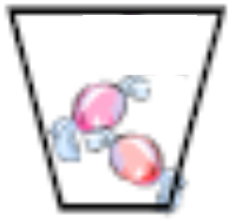  Written methods  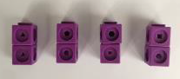  Language and model must match – show by indicating one group  [e.g. using loops or build/make groups] | Mental Methods  Sharing:  Share a group of objects equally between 2 groups  e.g. sharing objects between 2 plates: Share 14 buttons between 2 dishes.  2 + 2 + 2 + 2 = 8  There are 4 pairs of two.  Grouping: In context  Divide quantities into equal groups.  How many 2’s are there in 10?
Y1 | MASTERY - The Big Ideas (NCETM)  Counting in steps of equal sizes is based on the big idea of ‘unitising’ ; treating a group of, say, five objects as one unit of five.  Working with arrays helps pupils to become aware of the commutative property of multiplication, that 2 × 5 is equivalent to 5 × 2. |  | Vocabulary  groups of, lots of, times, array,  altogether, multiply, count  share, share equally, one each,  two each..., group, groups of, lots  of, array  Odd, Even  Multiply, Multiplication, Times, Product  Repeated addition  Array  Divide, Division  Groups, Grouping, Sharing

Year | Addition | Subtraction
Y2 | Mental Methods  Pupils will add with 2-digit numbers developing mental methods with greater fluency  [including bonds to 100 with multiples of 10 e.g. 30 + 70 = 100].  Written Methods  - Pupils will add 2-digit numbers and 1-digit numbers and add 10s to 2-digit numbers  Pupils will be taught how to add two 2-digit numbers, using examples that do not cross the tens boundary e.g. 24+45=?  - Partition both numbers then add together the ones first then add the tens.  Use the Base 10 blocks first before moving onto place value counters (or coins) again using examples that do not cross the tens boundary…  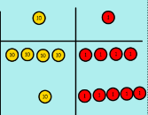  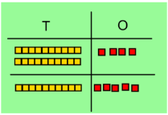  24 + 15= 44 + 15 = 24 + 45 =  Tens Units | 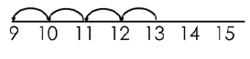  Mental Methods  Pupils should subtract on a marked number line by counting back.  They will be taught to recognise that when numbers are close together, it is more efficient to count on to find the difference.  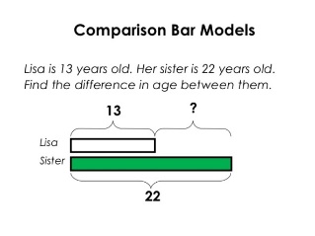  Understanding the relationship between addition and subtraction needs to be continually reinforced.  Written Methods  Pupils will use a number line to subtract one and two digit numbers from a two digit number.  34 35 36 37 38 39 49 59  Pupils will be taught to bridge through 10:
Y2 | MASTERY - The Big Ideas (NCETM)  Understanding that addition of two or more numbers can be done in any order supports children’s fluency. When adding two numbers it can be more efficient to put the larger number first. E.g. 3 + 8 it is easier to calculate 8 + 3. When adding three or more numbers it is helpful to look for pairs of numbers that are easy to add. E.g. given 5 + 8 + 2.  Understanding the importance of the equals sign meaning ‘equivalent to’. Empty box problems can develop this key idea.  Correct use of the equals sign should be reinforced at all times. Altering where the equals sign is placed develops fluency and flexibility further.  Pupils use a bar model to explore addition and subtraction facts and the relationship  between them. |  | Vocabulary  sum, tens, units, partition, addition, column, tens boundary  difference, strategy, partition, tens, units  Add, subtract  Count on, count back  More, less  Plus, minus, total, sum  Difference between  Partition, Bridge, Round, adjust  Inverse  Number line  Number facts  Multiple of ten, tens boundary

Year | Multiplication | Division
Y2 | Mental Methods  Children should begin to recall multiplication facts for 2x to 10x tables.  Written Methods  Children should be taught to multiply using arrays and repeated addition.  - To use arrays to visualise patterns…  - To use practical apparatus e.g. beads to count on in repeated blocks.  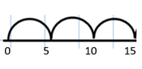  - To use an empty number line to count on.  …and make links between all three representations.  Scaling  (Note: this image can introduce multiplication as scaling.  “Start with a length of 5 and make it 3 times longer.” | Mental Methods  To begin to understand that division is the inverse of multiplication.  Written Methods  Children should be taught to group or share using ÷ and = signs.  They can use hoops and objects to illustrate the idea of sharing.  They should know and understand sharing and grouping. e.g. 6 ÷ 2 =  Sharing – 2 indicates the number of groups to share equally between.  Grouping – 2 indicates the size of each group.  They should begin to group using a number line. This should be modelled so pupils can develop the skill of ‘chunking’ in KS2.
Y2 | MASTERY - The Big Ideas (NCETM)  It is important that pupils both commit multiplication facts to memory and also develop an understanding of conceptual relationships. This will aid them in using known facts to work out unknown facts and in solving problems.  Pupils should look for and recognise patterns within tables and connections between them (e.g. 5× is half of 10×).  Pupils should recognise multiplication and division as inverse operations and use this knowledge to solve problems. They should also recognise division as both grouping and sharing.  The recognition of pattern in multiplication helps pupils commit facts to memory, for example doubling twice is the same as multiplying by four, or halving a multiple of ten gives you the related multiple of five. |  | Vocabulary  multiplied by, repeated, addition, column, row, commutative, sets of, equal groups, times as big as, once, twice, three times  divide, divided by, divided into, division, grouping, number line, left, left over  Multiplication table, Times table  Odd, Even  Multiply, Multiplication, Times, Product  Repeated addition, Array  Divide, Division  Inverse  Operation  Notation: ×, ÷ and = signs

Year | Addition | Subtraction
Y3 | Mental Methods  Children should have a good understanding of place value.  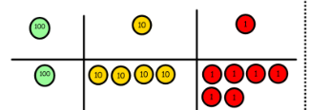  Add a 3-digit number and ones mentally  Add a 3-digit number and tens mentally  Add a 3-digit numbers and hundreds mentally  e.g. start with the number 146…  “What is 10 more?.. 100 more?”  Written Methods  Add numbers with up to 3-digits  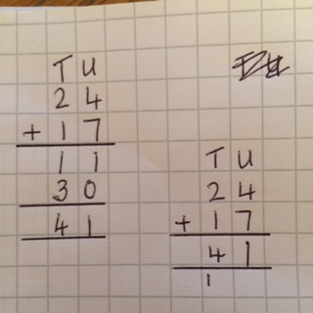  They should partition the numbers and then add the units first, then the tens and hundreds etc before adding together to make the total.  Children need to understand place value and what they are adding in each column e.g. the 7 and 8 are 7 tens add 8 tens.  Move to the compact column addition method, with ‘exchanging’:  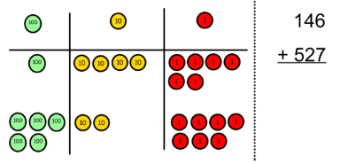 | Mental Methods  Subtract mentally a 3-digit number and ones  Subtract mentally a 3-digit number and tens  Subtract mentally a 3-digit numbers and hundreds  Written Methods  Subtracting with 2 and 3 digit numbers (introduce partitioned column subtraction method)  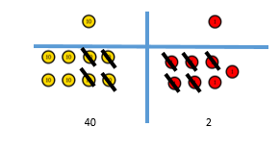  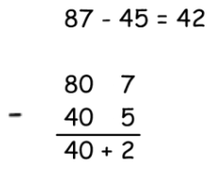  Move on to exchanging tens, using apparatus to model, to develop children’s understanding.  Next step – moving on to hundreds, tens and units.
Y3 | MASTERY - The Big Ideas (NCETM)  Relating numbers to 5 and 10 helps develop knowledge of the number bonds within 20. E.g. 8 + 7, thinking of 7 as 2 + 5, and adding the 2 and 8 to make 10, then the 5 to 15. This should then be applied when calculating with larger numbers.  Subtraction bonds can be thought of in terms of addition: for example, in answering 15 – 8, thinking what needs to be added to 8 to make 15. Counting on for subtraction is a useful strategy that can also be applied to larger numbers.  What do you notice?  Is there a relationship between the calculations?  Write the four number facts that this bar model shows. |  | Vocabulary  hundreds, boundary, increase, vertical, , expanded, compact  exchange, ‘carry’, decrease, hundreds, value, digits  partition, Calculation, Calculate  Addition, Subtraction, Sum, Total  Difference, Minus, Less  Column addition, Column subtraction  Operation  Estimate  Inverse  Operation
  500 + 400 =  400 + 500 =  300 + 600 =  200 + 700 =  100 + 800 = | 523 + 400 =  423 + 500 =  323 + 600 =  223 + 700 =  123 + 800 = | 523 + 28 =  423 + 28 =  323 + 28 =  223 + 28 =  123 + 48 =

Year | Multiplication | Division
Y3 | Mental Methods  Recall and use multiplication facts for the 2, 3, 4, 5, 8 and 10 times tables, and multiply multiples of 10. e.g. 4 x 8 =  - Either start with 4 double it (8), double it(16) , double it(32)  - Or start with 8 double it(16) , double it(32)  Develop fluency in mental strategies using the commutative law  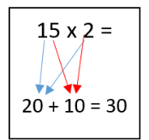  e.g. 3 x 11 x 5 = 5 x 11 x 3 = 55 x 3  and the distributive law  e.g. 15 x 2 = 10 x 2 + 5 x 2  Develop fluent mental methods to solve a range of problems  Written Methods  - Multiply 2-digits by a single digit number develop understanding of use of arrays  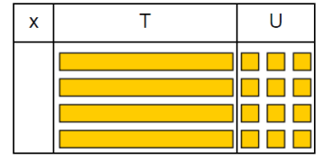  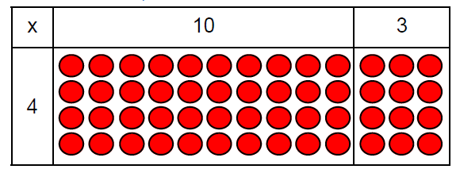  - Introduce the grid method for multiplying 2-digit by single – digits: e.g. 34 x 7  Children should be confident in partitioning as well as multiplication knowledge.  Note: They may make errors with the multiplying aspect, although be fine adding the amounts together, which is easily shown using this method.  210 + 28 = 238  (Children to use an appropriate method for the addition) | Mental Methods  Recall and use multiplication and division facts for the 2, 3, 4, 5, 8 and 10 times tables, (through halving connect the 2, 4 and 8 tables) e.g. 32÷4 = Start with 32 halve it(16), halve it(8)  Develop efficient mental methods e.g. using multiplication and division facts to derive related facts  Written Methods  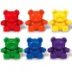  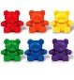  Divide 2-digit numbers by a single digit – where there is no remainder in the final answer, then with remainders.  Model grouping on a number line:  - As repeated addition [counting on]  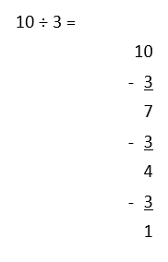  - As repeated subtraction [counting back]  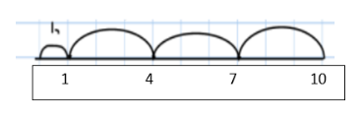  This can also be done vertically – beginning ‘chunking'  Short Division  When introducing - limit numbers to no exchanges… then with exchanges.  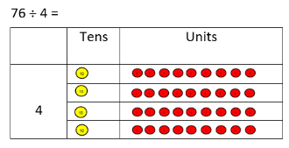  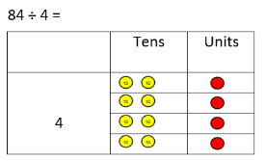
Y3 | MASTERY - The Big Ideas (NCETM)  It is important for children not just to be able to chant their multiplication tables but also to understand what the facts in them mean, to be able to use these facts to figure out others and to use in problems. It is also important for children to be able to link facts within the tables (e.g. 5× is half of 10×).  They understand what multiplication means, see division as both grouping and sharing, and see division as the inverse of multiplication. |  | Vocabulary  exchange, decrease, hundreds, value, digits  partition, grid method, multiple, product, tens, units, value  inverse, short division, ‘carry’, remainder, multiples  Multiplication table, Times table  Multiply, Multiplication, Times, Product  Divide, Division  Inverse  Operation, Estimate

Year | Addition | Subtraction
Y4 | Mental Methods  Continue to practise a wide range of mental addition strategies e.g. number bonds, adding to the nearest multiple of 10, 100, 1000 using near doubles, adjusting and partitioning and recombining.  Estimate and check solutions using mental strategies. e.g.  Calculations should be presented as horizontal number sentences (to promote mental strategies).  Written Methods  Add numbers with up to 4 digits.  When setting out in the vertical format, digits/ columns should be correctly aligned.  Children should move from the expanded addition method to the compact column method, adding units first and ‘carrying’ [exchanging] numbers underneath the calculation.  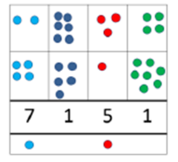  Make sure children have a clear understanding of place value and understand the importance of this.  Pupils should be taught to solve sums including money and measures contexts and add units first, ‘carry’ [exchanging] numbers underneath the bottom line and reinforce correct place value by reminding them of the actual value of the ‘carry’. | Mental Methods  Find a 1000 less than a given number.  Count backwards through 0, including negative numbers  Estimate and check solutions using mental strategies.  Written Methods  Subtract with up to 4-digit numbers  Begin with the partitioned method with decomposition.  Knowledge of place value is very important. Children should understand decomposition before moving to the compact method.  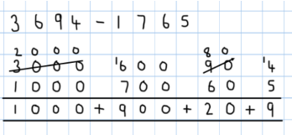  Move on to compact column subtraction  When setting out in the vertical format, digits/ columns should be correctly aligned.
Y4 | MASTERY - The Big Ideas (NCETM)  It helps to round numbers before carrying out a calculation to get a sense of the size of the answer. For example, 4786 – 2135 is close to 5000 – 2000, so the answer will be around 3000. Looking at the numbers in a calculation and their relationship to each other can help make calculating easier. For example, 3012 – 2996. Noticing that the numbers are close to each other might mean this is more easily calculated by thinking about subtraction as difference. |  | Vocabulary  thousands, hundreds, digits, inverse  Addition, Subtraction  Sum, Total  Difference, Minus, Less  Column addition, Column subtraction  Exchange  Operation  Estimate

Year | Multiplication | Division
Y4 | Mental Methods  Count on in multiples of 6,7,9, 25 and 1000  Recall multiplication facts for all multiplication tables up to 12 x 12  Use place value, known facts and derived facts to multiply mentally fluently  Approximate before they calculate and make this a regular part of their calculating.  Written Methods  Multiply 2 and 3-digits by a single digit, using all multiplication tables up to 12x12  Developing the grid method  - TU x U =  210  + 28  238  - HTU x U =  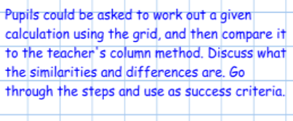  [Note: This method shows clearly where errors may occur. The procedure may be correct, but their multiplication or addition skills may be a problem, if the answer is incorrect.] | Mental Methods  Count back in multiples of 6, 7, 9, 25 and 1000 [from any given number].  Recall multiplication and division facts for all multiplication tables up to 12 x 12  Use known facts to support new facts… e.g. 7 x can be calculated by adding 5 x and 2 x  7 x 8 = 5 x 8 + 2 x 8  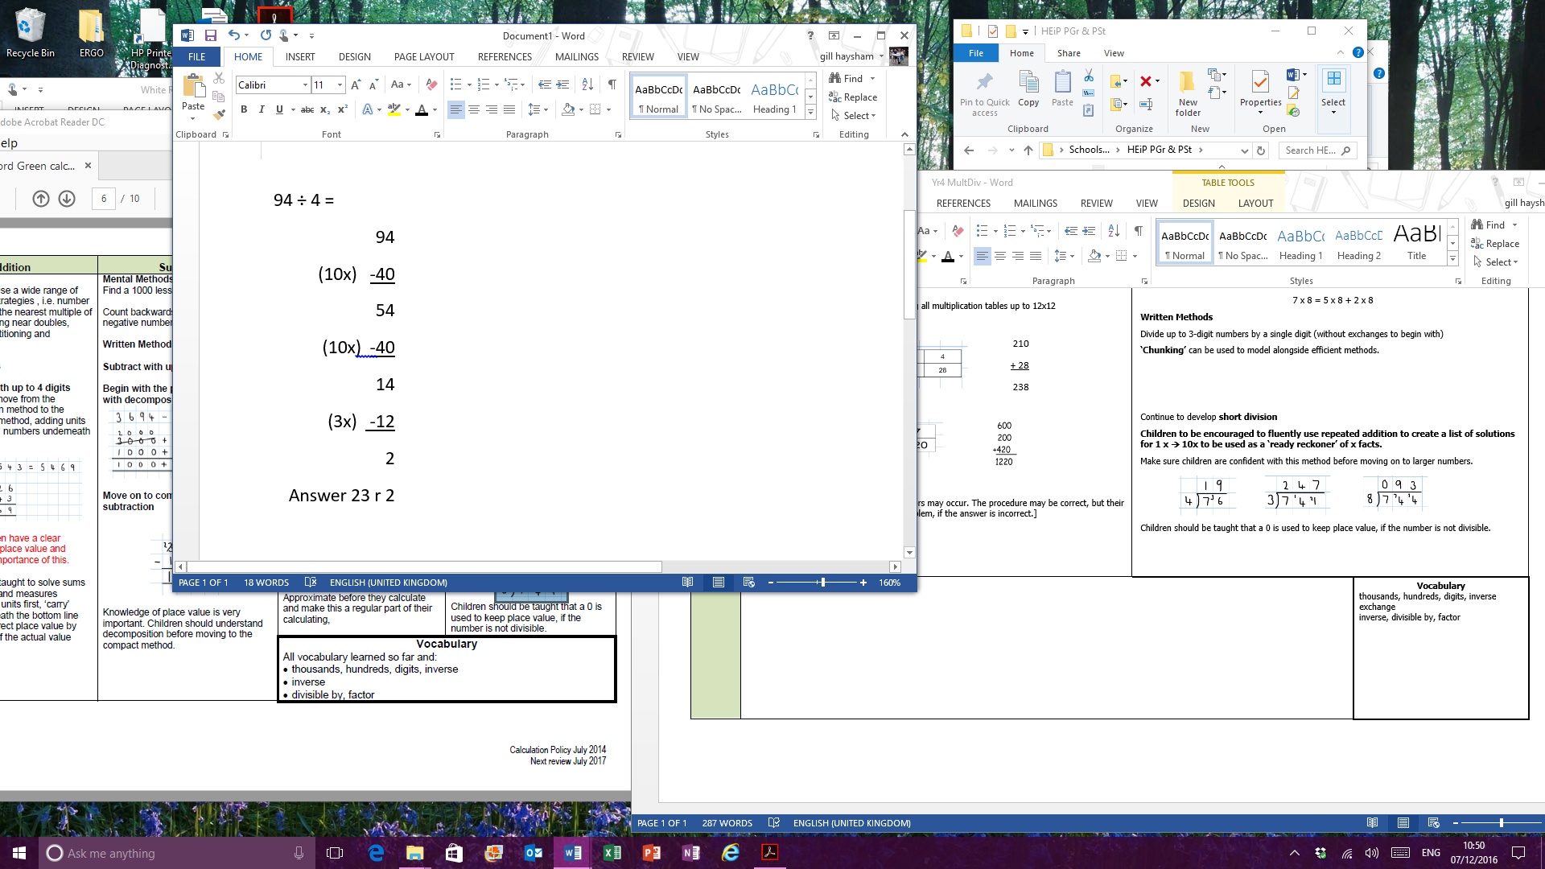  Written Methods  Divide up to 3-digit numbers by a single digit (without exchanges to begin with)  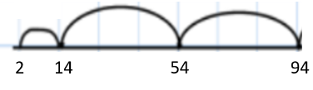  ‘Chunking’ can be used to model alongside efficient methods.  Continue to develop short division  Make sure children are confident with this method before moving on to larger numbers.  Children should be taught that a 0 is used to keep place value, if the number is not divisible.  Children to be encouraged to fluently use repeated addition to create a list of solutions for 1 x 10x of the divisor [to be used as a ‘ready reckoner’ of x facts].  e.g. 744 ÷ 8 = …writing ‘8, 16, 24, 32, 40, 48, 56, 64, 72, 80’
Y4 | MASTERY - The Big Ideas (NCETM)  It is important for children not just to be able to chant their multiplication tables but to understand what the facts in them mean, to be able to use these facts to figure out others and to use them in problems.  It is also important for children to be able to link facts within the tables (e.g. 5× is half of 10×).  They understand what multiplication means and see division as both grouping and sharing, and to see division as the inverse of multiplication.  The distributive law can be used to partition numbers in different ways to create equivalent calculations. For example, 4 × 27 = 4 × (25 + 2) = (4 × 25) + (4 × 2) = 108.  Looking for equivalent calculations can make calculating easier. For example, 98 × 5 is equivalent to 98 × 10 ÷ 2 or to (100 × 5) – (2 × 5). The array model can help show equivalences. |  | Vocabulary  digits, inverse  exchange  inverse, divisible by, factor  Place value  Multiply, Multiplication, Times, Product  Divide, Division  Tenth, hundredth,  Factor pairs  Short multiplication  Operation  Estimate

Year | Addition | Subtraction
Y5 | Mental Methods  Add numbers mentally with increasingly larger numbers, using and practising a range of mental strategies i.e. add the nearest multiple of 10, 100, 100 and adjust; use near doubles, inverse, partitioning and re-combining; using number bonds [practise for increased fluency].  Estimate and check solutions using mental strategies.  All strategies lead to increased fluency.  Written Methods  Add numbers with more than 4 digits (including money, measures and decimals with different numbers of decimal places)  Numbers should exceed 4 digits  Moving on to add more than two values  Pupils should:  Understand the place value of tenths and hundredths and use this to align numbers with different numbers of decimal places.  [Example: adding ‘0’ as a place holder] | Mental Methods  Subtract numbers mentally with increasingly larger numbers  Written Methods  Subtract with at least 4–digit numbers  Children to use compact column subtraction once confident with the partitioned column method.  Children to begin subtracting with larger integers before moving on to decimals.  Zero can be added to empty decimal places (up to 2 dp) to aid understanding of what to subtract in that column.  Pupils should:  Be confident in solving subtraction calculations in a range of contexts, including money and measures.
Y5 | MASTERY - The Big Ideas (NCETM)  Before starting any calculation is it helpful to think about whether or not you are confident that you can do it mentally. For example, 3689 + 4998 may be done  mentally, but 3689 + 4756 may require paper and pencil. Carrying out an equivalent calculation might be easier than carrying out the given calculation. For example 3682 – 2996 is equivalent to 3686 – 3000 (constant difference). |  | Vocabulary  Addition, Subtraction  Sum, Total  Difference, Minus, Less  Column addition, Column subtraction  Exchange  Operation  Estimate  decimal places, decimal points, tenths, hundredths and thousandths

Year | Multiplication | Division
Y5 | Mental Methods  Identify multiples, factors, square, cube and prime numbers, using knowledge of multiplication tables to 12 x 12  Use place value understanding to derive new facts e.g. 4 x 6 = 24  40 x 6 = 240 400 x 6 = 2400 4000 x 6 = 2400 40 x 60 = 2400 400 x 60 = 24000  Written Methods  Multiply up to 4-digits by 1 or 2 digits  Short multiplication for multiplying by a single digit  Explaining multiplying by multiples of 10 and 100 above:  “6 x ‘4 hundreds’ = 24 hundreds” AND/ OR “6 x 4 x 100 = 2400“  “6 x 3 tens = 18 tens” “6 x 3 x 10 = 180”  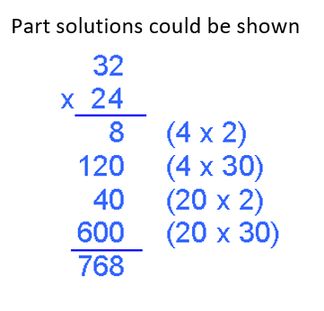  Introduce long multiplication for multiplying by 2 digits  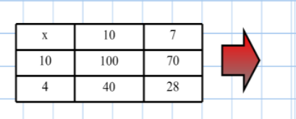  …moving on to more complex numbers up to 4-digit x 2-digit. | Mental Methods  Recall multiplication and division facts for all numbers to 12 x 12  Divide numbers mentally, using known facts  Written Methods  Divide up to 3 digits by a single digit, without remainders initially  [As Year 4, create ‘ready reckoner’ for divisor: 7, 14, 21, 28, 35, 42, 49, 56, 63, 70]  Chunking methods from previous year groups can be still be used to support children’s progression to more efficient methods.
Y5 | MASTERY - The Big Ideas (NCETM)  Pupils have a firm understanding of what multiplication and division mean and have a range of strategies for dealing with large numbers, including both mental and  standard written methods. They see the idea of factors, multiples and prime numbers as connected and not separate ideas to learn.  They recognise how to use their skills of multiplying and dividing in new problem solving situations.  Fractions and division are connected ideas: 36 ÷ 18 = 36/18 = 2; 18/36 = ½  Factors and multiples are connected ideas: 48 is a multiple of 6 and 6 is a factor of 48. |  | Vocabulary  decimal places, decimal point, tenths, hundredths and thousandths  square, factor, cube, integer, decimal, short multiplication, long multiplication, exchange (‘carry’), quotient, prime number, prime factors, composite number  Multiply, Times, Product  Divide, Division, Divisible  Divisor, Quotient, Estimate,  Remainders ‘r ’

Year | Addition | Subtraction
Y6 | Mental Methods  Perform mental calculations, including mixed operations and large numbers, using and practising a range of mental strategies.  Estimate and check solutions using mental strategies.  All strategies leading to increased fluency.  Written Methods  Add several numbers of increasing complexity  Add several numbers with different numbers of decimal places. Tenths, Hundredths and thousandths should be correctly aligned, with the decimal point lined up vertically including in the answer. Children can place zeros in empty decimal places, to show ‘no value’ to add and to aid them with keeping place value of numbers correct.  Pupils should:  Calculate in context, to include money and measures. | Mental Methods  Perform mental calculations, including mixed operations and large numbers, using and practising a range of mental strategies.  Estimate and check solutions using mental strategies.  Written Methods  Subtracting with increasingly larger and more complex numbers including decimal values up to 3dp.  Pupils should:  Use the compact column method to subtract more complex integers. Using this method to subtract money and measures as well, including decimals with different numbers of decimal places. Empty decimal places can be filled with zero to show the place value in each column. Pupils should be able to apply their knowledge to select the most appropriate method to work out subtraction problems.
Y6 | MASTERY - The Big Ideas (NCETM)  Deciding which calculation method to use is supported by being able to take apart and combine numbers in many ways. E.g. 8·78 + 5·26 might involve calculating 8·75 + 5·25 and then adjusting the answer.  The associative rule helps when adding three or more numbers: 367 + 275 + 525 is probably best thought of as 367 + (275 + 525) rather than (367 + 275) + 525.  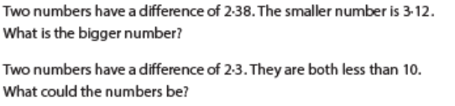 |  | Vocabulary  Addition, Subtraction  Sum, Total  Difference, Minus, Less  Column addition  Column subtraction  Operation  Approximate (noun and verb)  Estimate (noun and verb)  Round  Decimal place  Check  Solution, Answer  Order of magnitude  Accurate, Accuracy

Year | Multiplication | Division
Y6 | Mental Methods  Recall multiplication facts for all times tables up to 12 x 12.  Derive new facts appropriate to for the given calculation.  E.g. Example below  0.02 x 3 = 0.06 using 2 x 3 = 6  0.9 x 3 = 2.7 using 9 x 3 = 27  Written Methods  Short and long multiplication as in Y5, and multiply decimals with up to 2 decimal places by a single digit. When recording, decimal points should be aligned.  Estimate first 5 x 3 = 15…  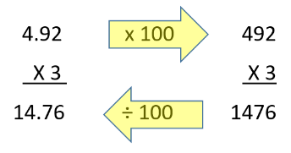  Alternately:  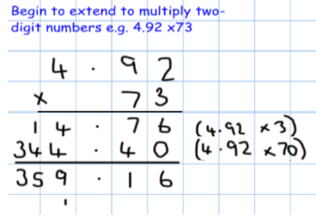  Children should be able to:  Use rounding and place value to estimate answers before calculating and use to check their answers. | Mental Methods  Recall division facts for all times tables up to 12 x 12.  Written Methods  Divide at least 4 digits by both single-digit and two-digit numbers (including decimals up to 2dps and quantities)  Short division, for dividing by a single digit:  ‘Ready Reckoner’: 8, 16, 24, 32, 40, 48, 56, 64, 72, 80  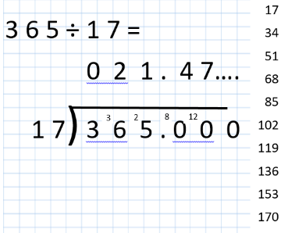  Short division, for dividing by a 2-digit number:  Refine accuracy of solutions:  Any ‘remainders’ should be shown as fractions, and extended to decimals
Y6 | MASTERY - The Big Ideas (NCETM)  Standard written algorithms use the conceptual structures of the mathematics to produce efficient methods of calculation.  Standard written multiplication method involves a number of partial products. For example, 36 × 24 is made up of four partial products 30 × 20, 30 × 4, 6 × 20, 6 × 4.  There are connections between factors, multiples and prime numbers and between fractions, division and ratios. |  | Vocabulary  extending multiplication with tenths, hundredths and decimals  Common factor  Divide, Division, Divisible  Divisor, Dividend, Quotient, Remainder  Factor

